Process Report

Fresh Fitness

Group 8:

Jaser Ghasemi - 267243

Yasin Issa Aden - 267276

Modaser Ghasemi - 267251

Supervisors:

Ole Ildsgaard Hougaard

Jakob Knop Rasmussen

Christian Flinker Sandbeck

Erland Kertil Larsen

Line LIndhardt Egsgaard

Jan Munch Pedersen

**Software engineering**

**3rd semester**

**(Date)**

Version: August, 2018

Template responsible: dans@via.dk

**Table of content**

Preface iii

1 Introduction 1

2 Group Description 2

3 Project Initiation 3

4 Project Description 4

5 Project Execution 5

6 Personal Reflections 6

7 Supervision 7

8 Conclusions 8

Appendices

# Preface

Optional

# Introduction

# Group Description

When SEP3 began, one of the first tasks was to organize a SEP group. The team you decide to form is extremely important for the project’s future, and a lot of variables was considered. After some discussion our group was finally formed. The group contained three students from Viborg, and because of an exception, this group was allowed to have three students with the same nationality. Based on SEP2 the group now had a different approach to this project, since a lot of problems occurred regarding our planning.

One of the obstacles for the group was the travel distance from Viborg and Horsens. The travel time would approximately take 2,5 hours each way. The group members would have to spend five to six hours just on travel time. This led to the group deciding to work from home most of the time, but this came with a cost. It was hard to get help because the group relied on using emails back and forth, in order to get help from the supervisors, and emails were not as efficient as being next to the supervisor in real life and get help directly.

Another important thing to mention is that the group members were relatively close friends, and this meant they were aware of each other’s strengths, weaknesses, and personalities, which was both helpful and negative because the group members would often be more laid back and sometimes could lack taking responsibility of own individual tasks. The group members decided to give each other deadlines for individual tasks, and if a deadline was overdue, the member would have to pay for dinner.

The same group was also used in SEP2, and back then a lot of challenges happened. First of all, due to a misunderstanding and miscommunication the group started to code the entire system in the last the 2 weeks of the project. This understandably led to a system that was unfinished, which affected the overall result and in the grading. Luckily, we passed and could take this as a lesson and experience for the new SEP3. In this SEP the group made it a priority to begin the coding in good times to tackle the inevitable challenges that will happen in that process.

Once the idea was approved by the supervisors, the group started to focus on the project by creating a schedule and organizing tasks. The group decided to create a group policy to abide by, in order to secure efficient teamwork. Once every member had signed the group policy it was decided that the group would meet up during Thursdays and work on the SEP project.

To be able to track the work done, the group structured the project in a SCRUM, with 5 sprints. First, the inception phase, where use cases were made, which later became the use case diagram. Secondly, the analysis phase where the classes necessary for the system were made, and afterward the analysis class diagram was made. Thirdly, the design phase where the methods for these classes were decided. After the Design phase it was time to implement the system, and lastly, the system would be tested.

# Project Initiation

The project initiation consists of three phases, group formation, project requirements and group tools. These phases are important to form an overview of the project initiation of group 8.

## Project requirements & topic selection

Requirements for this project was to make a system consisting of 3-tier architecture and that is heterogeneous, meaning that it would be coded in different languages in this case Java and C#. Furthermore, the consume and expose a web service, and a protocol should be designed and used for sockets. Lastly, a GUI should be made for each client.

When selecting a fitting topic that would encapsulate all the different topics, we got the idea for Fresh Fitness. The goal of this system is to create a three-tier distributed system with two or more centers. One center in Viborg and one in Horsens. The centers should have different subscription types. A regular member that only can access user interface to see workout sessions for that center only, and a premium member that can access the user interface and join sessions for both centers. Both centers have a three-tier-architecture consisting of:

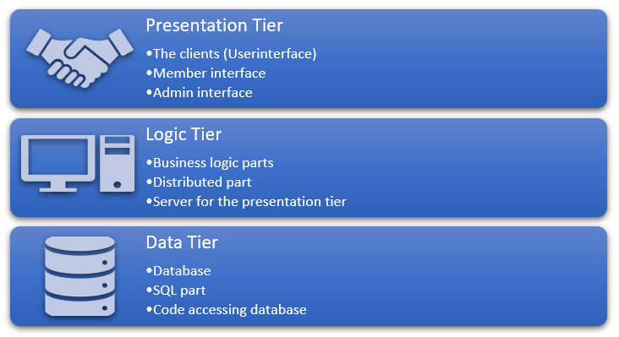

There is a p2p connection between the two centers (distributed system). This means that in the logic there will be a connection between the two centers where they will work as both clients and servers respectively. Each center has a database. Now the two databases need to connect, this is done by having a different id for each center. To make the systems heterogenous the one of tier could be coded in another language.

## group formation

In this phase, the group was formed. The group formed was Jaser, Modaser, and Yasin. The group formation was based on the friendship and distance this these members had. This was convenient due to every member living in Viborg. When forming this group, the thought of being able to work together effectively was kept in mind. Furthermore, due to the distance, other class members were hesitant to work together with us. Another thought when forming this group was because of the good relationship we had. We all respect each other’s idea and thoughts and were willing to listen to each other respectively. So, the threat of having internal group conflicts would be relatively low.

More knowledge about coding has been learned since last semester. Although we are still relying on the help from our teachers. We are also more experienced in how to handle projects compared to last semester, due to the challenges we faced. Overall, we as a team feel that we are better prepared to tackle this project, however the difficulty has increased a lot.

## Group tools & planning tools

The tools needed to succeed in this project was given to us by the teachers. We had Astah for the making the diagrams, Eclipse and Visual Studio Code for the coding, and PGAdmin 4 for the database. Furthermore, we had a lot of PowerPoints, lessons and exercises from SDJ3, DNP, NES and SEP that we could use.

For communication we would meet up in the library of our home town or VIA. If we had to communicate from distance we all had each other’s phone number. We would also use studienet/itslearning, Facebook or other social media.

For the planning tools we used SCRUM sprints to keep track of important dates for tasks. Furthermore, a calendar with important dates relating to the project. We also use studienet to plan supervisor meetings and would write all of them down in our logbook. As mentioned we had a logbook to keep track of the process and accomplishments alongside SCRUM. For the most part our planning was successful, but occasionally we would face obstacles such as sickness or ending up stuck on a task. Sometimes, we would end up not finishing all planned tasks. To overcome these obstacles, we would find alternative solutions or change plans.

# Project Description

In the project description an overview of the problem was expected. This was done in the project description we have as an appendix. For the first phase an analysis of the problem should be made. The next phase is to define the problem. This was done with a purpose and a problem statement.

## Purpose

A fitness-based registrations system where the users are able to keep track off and join different workout sessions depending on their subscription.

## Problem Statement

The overall challenge is to create a system where users can have their own profiles, join workout sessions and keep track off upcoming sessions. The admin should be able to manage all this. This requires a lot of data to be transferred, stored and shared. The system will also be a distributed heterogeneous system. The system's components will be located on different networked computers, which then can communicate and coordinate their actions by passing messages. Furthermore, a client-server-based system needs to be implemented, which will use different languages.

Questions to be answered are the following:

1. How will the system be designed?
2. How will the system, which are coded in different languages be able to communicate?
3. How will the system be maintainable?

### Delimitations

* The users will not be able to look at other users’ profiles(privacy)

## Project goal

When coming up with the goal of the system it was important that it was achievable, but at the same time challenging for us to overcome. For that reason, we made sure that every goal we set for ourselves had elements of stuff we already were taught at VIA. This was the thought process we had while deciding the goal for our project. Another important factor in deciding the goal was ourselves and our personal experiences and skills since it would not make sense for us to create an overly complicated system when we have no experience and are only a group of three individuals.

In the process, a lot of small goals were made leading up to the final product. SCRUM was used here separating the full project into smaller achievable tasks. SCRUM also helped us to narrow down what we would focus on and to make sure that we would do everything we could to achieve it. Of course, our SCRUM process was not perfect, and some tasks were not completed, but for the most part, our goals were reached.

# Project Execution

For content see Appendix 2 “Process Report – VIA Engineering Guidelines”.

# Personal Reflections

For content see Appendix 2 “Process Report – VIA Engineering Guidelines”.

# Supervision

For content see Appendix 2 “Process Report – VIA Engineering Guidelines”.

# Conclusions

For content see Appendix 2 “Process Report – VIA Engineering Guidelines”.

**Appendices**

For content see Appendix 2 “Process Report – VIA Engineering Guidelines”.